DONATION RECEIPT
TAX RECORD FORM

Love our Community is a private, not for profit corporation and is tax exempt under Section 501 (c)(3) of the Internal Revenue Code.

Federal law provides that clothing and household goods must be in “good used condition or better” for tax deductions. All values are assigned by the donor. Please keep this signed form as your donation record.

Name__________________________________________________________________________________________
Address_______________________________________________________________________________________
City___________________________________________ State___________ Zip___________________________

DONATIONS | VALUE

No goods or services were provided by the organization.

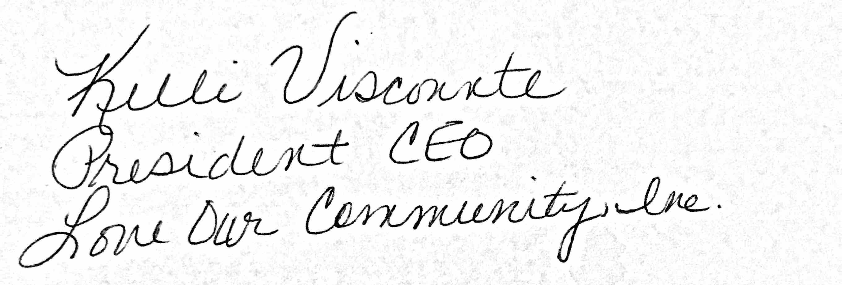__________________________________________________________________________

Love Our Community Representative Signature

